https://github.com/Xuefei-Guo/Database-A4

Commands:
- init connects to MySQL and prepares the SQLite analytics database.

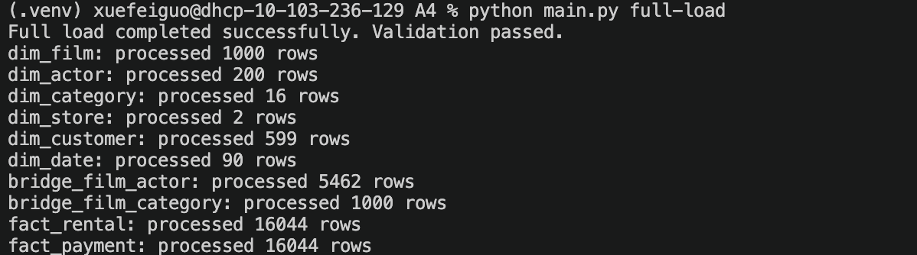
- full-load copies the Sakila data into SQLite and checks row counts and payment totals by store.

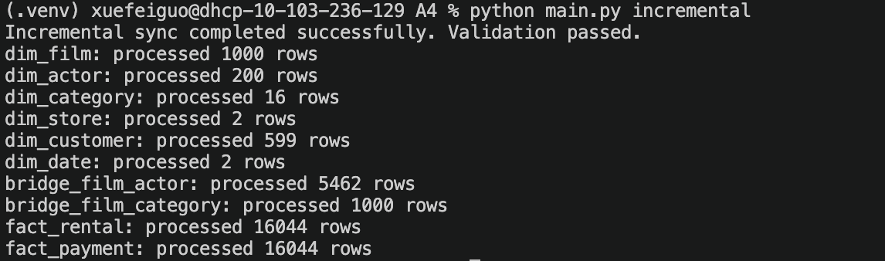
- incremental uses the saved last_update timestamps to synchronize new or changed records.

- validate compares rental counts, payment counts, and payment totals for the selected period. It also checks dimension records, duplicate source IDs, and missing dimension references.

Automated Tests:
The tests ran against a separate copy of Sakila and a temporary SQLite database. All five tests passed.
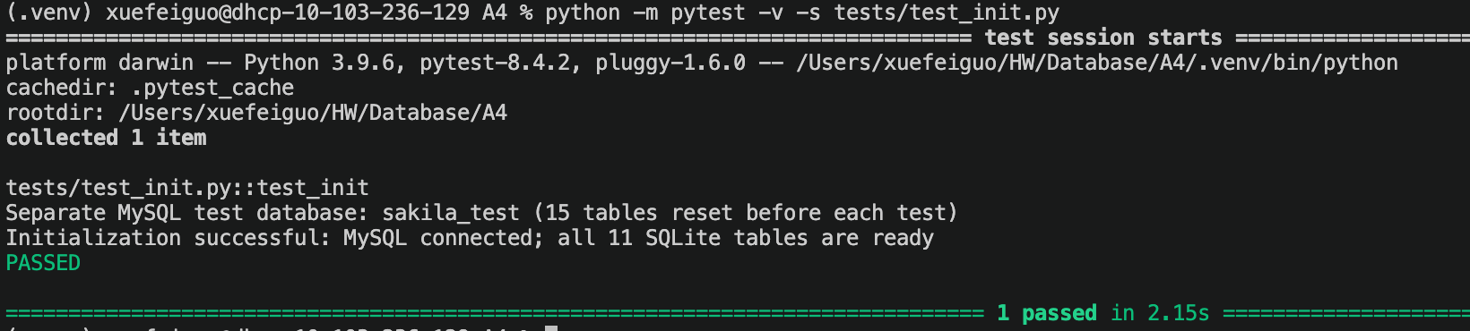
- Initialization. Verified that init created all 11 expected SQLite tables.

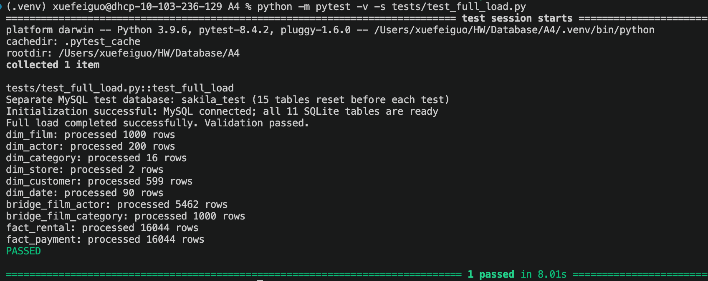
- Full load. Verified that MySQL and SQLite row counts matched for all nine mapped tables.
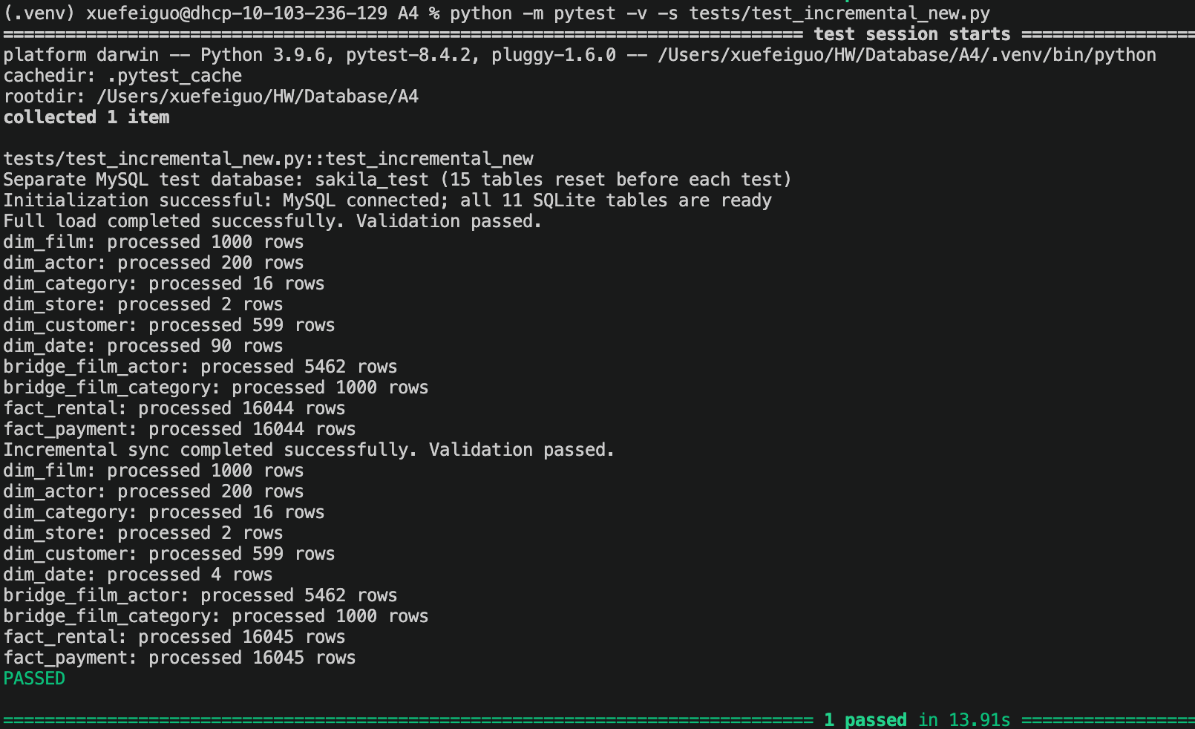
- Incremental inserts. Inserted a rental and a payment into MySQL and verified that their fields were copied correctly to SQLite.

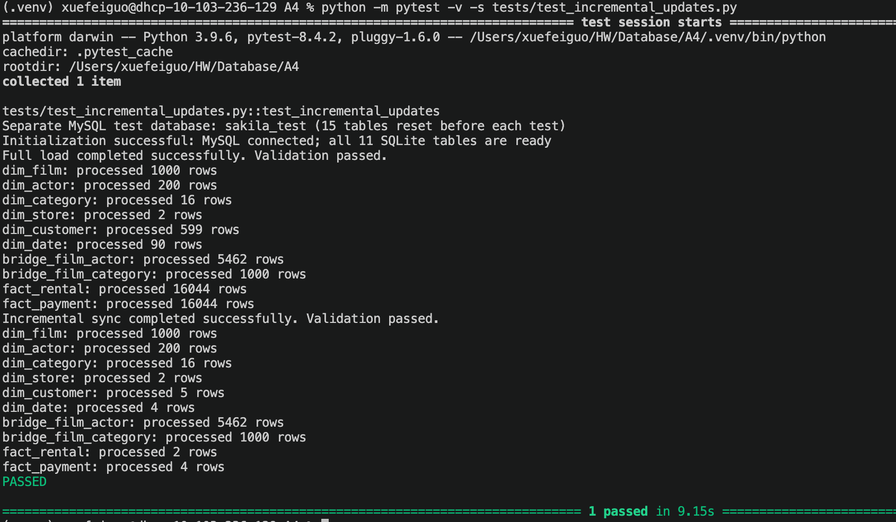
- Incremental updates. Verified that changing a customer’s address updated their city and country in SQLite, and that returning a rental updated its return date and duration.

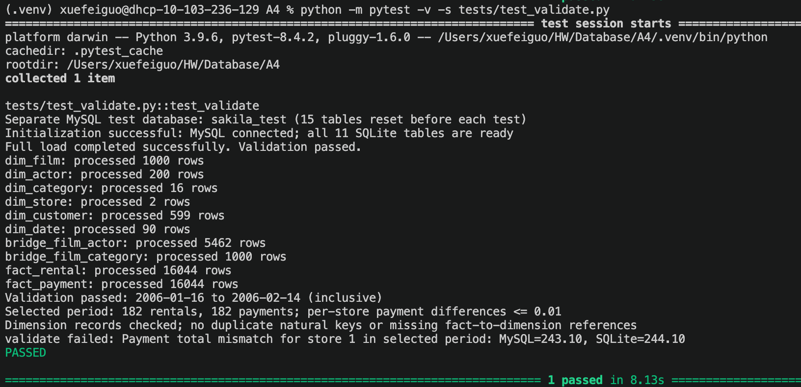
- Validation. Verified that consistent data passed validation and that increasing one SQLite payment by $1.00 triggered a payment total mismatch.

